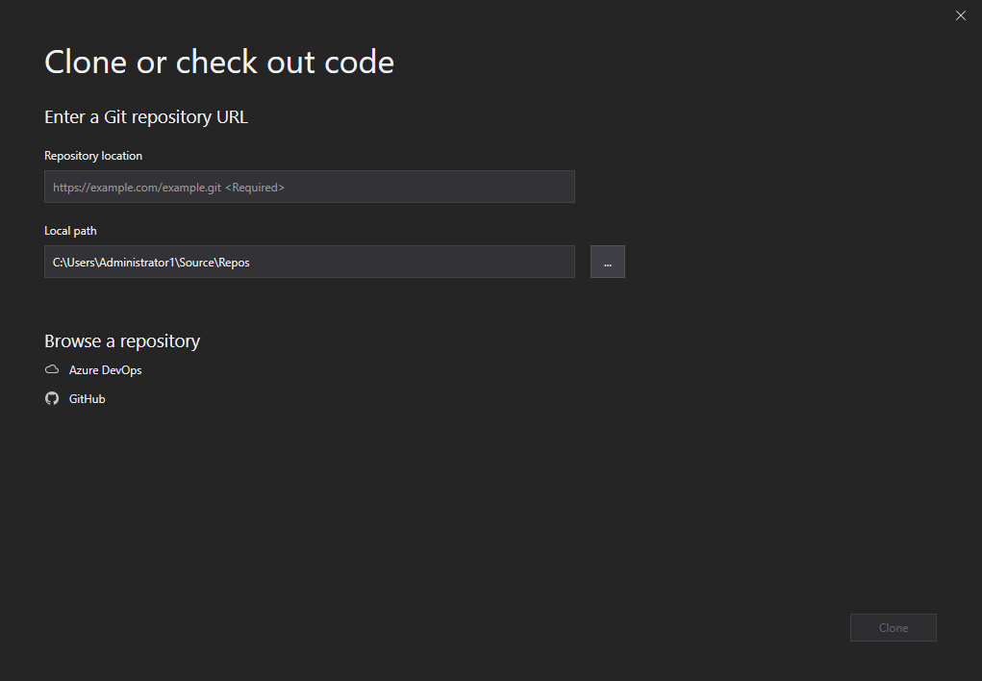

When getting started when hitting the clone option, you will be shown the above menu, by copying the clone link in the GitHub page <https://github.com/fedpy/DraganTalamh>. You paste the link into the Repository location field. And click clone on the bottom right of your screen and it will clone the repository into the local path which would be your repos folder.

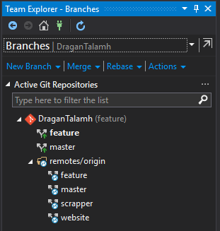

When the branches tab is selected in the team explorer menu. From here you have several options. You can:

* Create new branch using the “new branch” option which will allow you to make a new instance of the current branch which would allow you to demo new features or test out changes without affecting the larger
* Merging is an advanced tool, you can merge two branches together using the merge option. This will merge another branch into your currently selected branch.
* Rebase is an advanced option which should only be used by experienced members.
* Actions allow you to open the repo in the file explorer and open the command prompt in the currently selected repo.

In the active repositories section, you can view all branches of the project. you can tell which branch you are currently in by the branch name being in bold. You can change/checkout branches simply by clicking on the branch you want to checkout.